**Assignment 03 – Drupal 8 CMS Website (Taxonomy, Custom Content Types)**

**Instructions for completing template:**Replace **[bracketed red text]** with the requested information or screen capture.  
Replace **bracketed red text with black text** and then remove the brackets.  
Do not include full screen shot images, or full screen shots that are reduced in size. Use a snippet tool to capture parts of the screen and insert those images into the template.  
Do not remove tags from this template. Please answer all questions.  
**Please do not alter the formatting or delete parts of this template.**  
Assignment questions are not as detailed as activity questions.   
The assignment is where you demonstrate understanding of the material.

**Part A: Student Information**

1. **Student Name: [Abel Marin] [A01]**
2. **Class Designation: [REMOTE] [A02]**
3. **Student Contact Information: [marinabe1416@gmail.com] [A03]**
4. **What day and date did you start this assignment: [Monday March 9, 2020] [A04]**

**Go back to the instructions and begin work on part B.**

**Part B: Create 1 Shared Web Host Drupal 8 CMS Website**

(1) Shared Web Host Drupal 8 CMS Site Information:

Shared Web Host Name: [SiteGround] [B01]  
cPanel URL: [Enter cPanel URL here] [B02] *Only for hosts with separate URL for cPanel  
cPanel Username: [amarin13@gmail.com] [B03]   
cPanel Password: [Dbeu!315] [B04]  
Domain Name: [abelm.sgedu.site] [B05]  
In Directory Name: [assignment09] [B06]  
Website Admin Username: [ajmarin] [B07]  
Website Admin Password: [&L4$IWeZ#1] [B08]  
Database Name: [drup223] [B09]  
Table Prefix: [drnk_] [B10]  
Drupal 8 CMS Website URL: [http://abelm.sgedu.site/assignment09] [Front End URL] [B11]

*Note: Please do not provide the Backend for B11 (above).*

-OR-

(2) Pantheon – Drupal 8 CMS Site Information:

**Assignment Website Site Name:** **[Site Name here] [B01]**

**WEBSITE Admin Username:** **[Admin Username here] [B02]**

**WEBSITE Admin Password:** **[Admin Password here] [B03]**

**Pantheon Drupal 8 CMS Frontend Website URL:** **[Frontend website URL here] [B04]**

**Note: Please do not provide the Backend URL fro B04 above.**

**Go back to the instructions and begin work on part C.  
  
Part C: Identify Taxonomy-Vocabulary and Terms**

1. **How many Vocabularies did you identify? [C01]  
   [I counted 4 vocabularies.]**
2. **List the names of all Taxonomy-Vocabularies here. [C02]**

**[Image Type, Image Size, Direction, Season]**

1. **For each vocabulary, identify the vocabulary by name and list its terms here. [C03]  
   [Image Type: Wildlife, Commercial, or Pet;**

**Image Size: Medium, Large, or X-Large;**

**Direction: North, South, East, or West;**

**Season: Winter, Spring, Summer, or Fall] – add block for each vocabulary**

**Go back to the instructions and begin work on part D.**

**Part D: Create new custom content type**

1. SCREEN CAPTURE of the **“Photograph record” content type structure**   
   Admin toolbar > Struct > Content types, select Edit for the “Photograph record” item  
   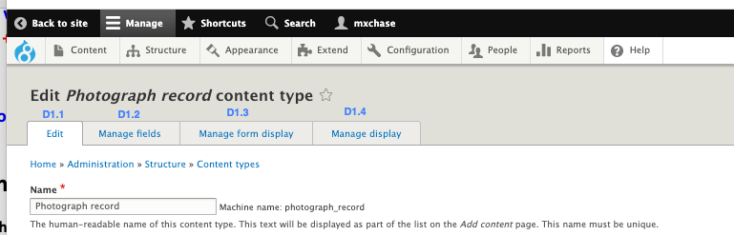  
   **[A screenshot of a computer screen

   Description automatically generated] [D1.1]**

**] [D1.2]  
] [D1.3]**

**] [D1.4]**

**Go back to the instructions and begin work on part E.**

**Part E: Add Website Content – Pages**

**1. SCREEN CAPTURE of the list of “Photograph record” nodes (records)  
 [**Admin toolbar > Content, filter by “Photograph record”] **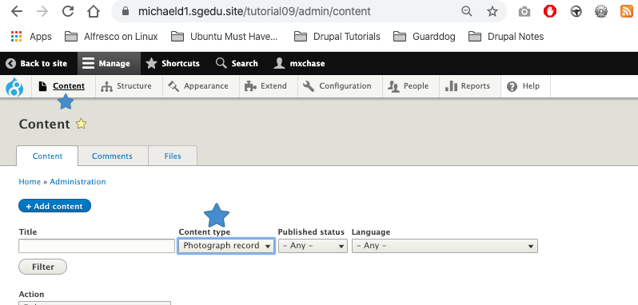  
] [E01]**

1. **SCREEN CAPTURE of one Photograph record #1 with Title: “Avocado Taste Great” [E02]**Please expand URL alias and Promotion options before taking the screen capture.  
   Use as many screen captures as it takes to display the whole page. **[A screenshot of a cell phone

   Description automatically generatedA screenshot of a cell phone

   Description automatically generated]**
2. **SCREEN CAPTURE of one Photograph record #3 with Title: “The Chickadee” [E03]**Please expand URL alias and Promotion options before taking the screen capture.  
   Use as many screen captures as it takes to display the whole page. **[A screenshot of a cell phone

   Description automatically generatedA screenshot of a cell phone

   Description automatically generated]**
3. **SCREEN CAPTURE of one Photograph record #5 with Title: “Portland Fish Market” [E04]**Please expand URL alias and Promotion options before taking the screen capture.  
   Use as many screen captures as it takes to display the whole page. **[A screenshot of a cell phone

   Description automatically generatedA screenshot of a cell phone

   Description automatically generated]**

**Go back to the instructions and begin work on part F.**

**Part F: View**

1. SCREEN CAPTURE of the backend **view list with “**My photograph view 1” visible **[F01]  
   Admin toolbar > Structure > Views, with “**My photograph view 1” visible

**]**

1. SCREEN CAPTURE of the backend **“**My photograph view 1” summary page **[F02] [F03]  
   Admin toolbar > Structure > Views, Edit** My photograph view 1  
   **[A screenshot of a computer screen

   Description automatically generated]   
   [A screenshot of a computer screen

   Description automatically generated]**
2. **SCREEN CAPTURE of the frontend** of the website showing the selected “My photograph view 1” main navigation meu option. Take multiple screen captures to show output form page 1 and 2.  
   Please make sure the web browser address bar is visible in the first image as well as the View Pager control at the bottom of the page. You can use multiple screen captures if necessary. **[F04] [F05]  
   [A screenshot of a computer screen

   Description automatically generated]   
   [A screenshot of a computer screen

   Description automatically generated]**

**Go back to the instructions and begin work on part G.**

**Part G – Drupal 8 Hook API:**

1. What are Drupal 8 API Hooks? **[G01]**  
   **[Drupal 8 API hooks define functions which change the behavior of Drupal core or another module. They are specially named functions which are defined within the module which are then invoked. ]**
2. What is the URL link where you can find a list of all the Drupal 8 Hooks? **[G02]**  
   **[ https://api.drupal.org/api/drupal/core!core.api.php/group/hooks/8.2.x ]**
3. In what Custom Module file do you enter Drupal 8 Hooks? **[G03]**  
   **[You would enter Drupal 8 hooks into the .module file of your custom module.]**
4. Write a general procedure of how you use the Hook code form the Drupal 8 Hook page to implement Hook Help in a Drupal 8 hook into a custom module. **[G04]**  
   **[I will be describing how to implement Hook Help on Codeanywhere. After finding the hook_help on the Drupal 8 hook page, you begin by copying the hook_help function into the .module file. Next, you change the name of the function by substituting the “hook” part for the custom module’s directory name. From here it’s just about editing the documentation of the document and changing the code of the function to fit your needs.]**

**Part H – Java Script libraries**

1. Does the libraries’ folder get created when you build a new Drupal 8 site? **[H01]**  
   **[No]**
2. What is the procedure for creating a libraries folder for a Drupal 8 site? **[H02]**  
   **[In SiteGround, you start by going to the file manager and selecting the Drupal 8 website folder under the public_html folder. Next you click the New Folder button. From here you type in libraries into the New Folder Name text field (it must be “libraries” no capital letters or anything). You then click the Create New Folder button. You are done and are free to install library zip files and extract them into this folder.]**
3. Screen capture of the File system showing the libraries folder and an extracted and fully expanded FlexSlider folder. **[H03]**  
   **[A screenshot of a computer screen

   Description automatically generated]**

**Part I– Assignment Wrap up:**

1. Did you work with other classmates on this assignment? [No] [I01]
2. Did you work with a tutor or volunteer on this assignment? [No] [I02]
3. Did you have any problem or issues other than time management completing this assignment? [I03] **This is not an optional question.   
   [Yes, my site was down for a good long time and I was not able to access it. This caused a delay for the tutorial and this assignment. I contacted SiteGround and they got it up and working again.]**If you answered yes to this question, please elaborate and be specific.  
   If you had trouble with a specific question, please identify it by number and explain what you did not understand or had problems with.  
   I can only improve this assignment with your help.

Submit this completed template to the D2L assignment 09 dropbox.If you prefer not to navigate by hand to the D2L dropbox, take advantage of the dropbox link in the D2L current Assignment section. This link will take you to the correct assignment dropbox location.